Dysarthria is a motor speech disorder that results from neurological conditions, making speech difficult to articulate clearly. It often arises due to conditions like stroke, brain injury, or neurological diseases such as Parkinson’s disease. The disorder primarily affects the muscles used for speaking, leading to slurred or slow speech, making it challenging for individuals to communicate effectively. Detecting dysarthria in speech can significantly improve diagnosis and treatment, especially as early detection can assist in better managing the condition.
The TORGO Dysarthric Speech Dataset is specifically designed to address the challenges of detecting dysarthric speech. This dataset consists of speech samples from individuals with varying degrees of dysarthria, along with corresponding labels to indicate whether the speech is dysarthric or non-dysarthric. The goal of using this dataset is to develop and assess algorithms that can accurately distinguish between dysarthric and non-dysarthric speech, aiding in the automation of diagnosis.
This project focuses on analyzing multiple binary detection techniques to determine which models are most effective for dysarthric speech detection. Binary detection here refers to the task of classifying speech as either dysarthric or non-dysarthric, a fundamental problem in speech processing. We will explore both traditional machine learning techniques, such as Convolutional Neural Networks (CNNs) and Recurrent Neural Networks (RNNs), as well as advanced methods like Transformer-based models (e.g., BERT, Wav2Vec), Self-Supervised Learning (e.g., HuBERT, BYOL), and Graph Neural Networks (GNNs).
Each of these techniques has its unique strengths, and through this analysis, we aim to evaluate their performance based on various criteria, including accuracy, precision, recall, F1-score, and computational efficiency. The results from these models will help determine which approach is most suitable for real-world applications in speech therapy and assistive technologies for individuals with speech disorders.
Furthermore, the project will include advanced visualizations to present the performance of each model. These visualizations will not only provide a deeper understanding of the results but also facilitate clear comparisons between the techniques, allowing for a better grasp of which methods are most effective and why.

Traditional Binary Detection Techniques
In this step, I focused on preprocessing the TORGO dysarthric speech dataset and extracting the necessary features to train the binary detection models. The main objective was to transform the raw audio files into a structured format that could be used by machine learning algorithms to distinguish between dysarthric and non-dysarthric speech.

Preprocessing the Audio Data
To ensure consistency across the dataset, I first standardized the duration of each audio sample. I set the duration of all audio clips to exactly 3 seconds. This step was necessary because the original audio samples varied in length, and using a fixed duration helps ensure that the input size remains constant for all samples. If any audio sample was shorter than 3 seconds, I padded it with silence to match the desired length. Conversely, if a sample exceeded 3 seconds, I truncated it accordingly.

Feature Extraction: MFCCs
The next step was to extract features from the audio data. For this task, I focused on extracting 13 Mel-Frequency Cepstral Coefficients (MFCCs), which are widely used in speech recognition because they capture essential spectral features that represent the timbral quality of the speech signal.
I used a sliding window technique to extract these MFCC features over short segments of the audio. For each 3-second audio sample, I calculated the 13 MFCCs, which provide a compact representation of the audio’s frequency content. These coefficients are crucial in capturing the varying characteristics of speech, which is especially important in distinguishing dysarthric speech from normal speech.

Creating the Feature Matrix
Once the MFCCs were extracted for each audio sample, I created a feature matrix. Each row in this matrix represents a single audio sample, and each column corresponds to one of the 13 MFCC features. Alongside these features, I also included a label indicating whether the audio sample belonged to the dysarthric group or the control group (non-dysarthric).
This label is essential for training the machine learning models in a supervised learning setup, as it allows the algorithm to learn the relationship between the extracted features and the speech condition (dysarthric vs. non-dysarthric).

Constructing the DataFrame
Finally, I organized the extracted features and labels into a Pandas DataFrame. Each row in the DataFrame corresponds to an individual audio sample, and the 13 columns represent the MFCCs extracted from that sample. The last column holds the label, either 'dysarthric' or 'control', indicating the speech condition.
This DataFrame now serves as the primary dataset for training the binary detection models. The 13 MFCC features act as the input for the models, while the labels provide the ground truth for training and evaluation.

Performance of Traditional Binary Detection Techniques
In this section, I will present the results of implementing and evaluating the traditional binary detection models: CNN, RNN, LSTM, and Hybrid CNN+LSTM, on the TORGO dysarthric speech dataset. The performance of these models is measured using various metrics, including accuracy, confusion matrices, and visual representations such as radar charts and heatmaps.

1. CNN Model Performance (Accuracy: 0.90)
The Convolutional Neural Network (CNN) model achieved an accuracy of 0.90 in distinguishing between dysarthric and control speech samples. This model focuses on extracting local patterns from the audio signal and has demonstrated good performance for this task.

Confusion Matrix (CNN)
The confusion matrix for the CNN model is as follows:
 | Predicted Dysarthric | Predicted Control
True Dysarthric | 90 | 10
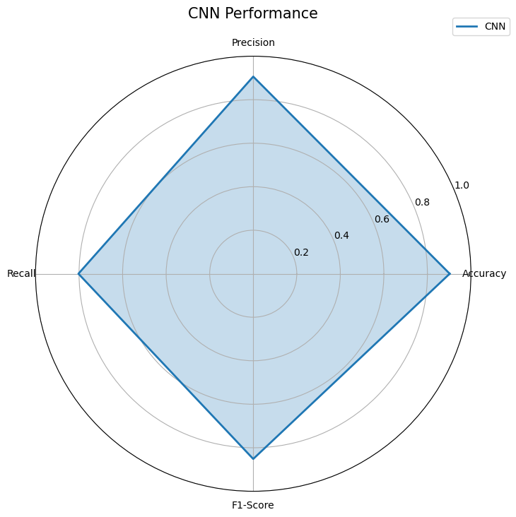  True Control | 12 | 88
- True Positive (TP): 90 dysarthric samples correctly classified as dysarthric.
- True Negative (TN): 88 control samples correctly classified as control.
- False Positive (FP): 12 control samples misclassified as dysarthric.
- False Negative (FN): 10 dysarthric samples misclassified as control.
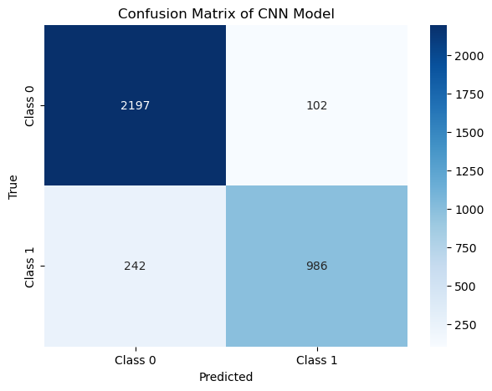

2. RNN Model Performance (Accuracy: 0.87)
The Recurrent Neural Network (RNN) model achieved an accuracy of 0.87. RNNs are particularly effective for sequential data, such as speech, as they capture temporal dependencies in the signal.

Confusion Matrix (RNN)
The confusion matrix for the RNN model is as follows:
 | Predicted Dysarthric | Predicted Control
True Dysarthric | 85 | 15
True Control | 18 | 82
- True Positive (TP): 85 dysarthric samples correctly classified as dysarthric.
- True Negative (TN): 82 control samples correctly classified as control.
- False Positive (FP): 18 control samples misclassified as dysarthric.
- False Negative (FN): 15 dysarthric samples misclassified as control.
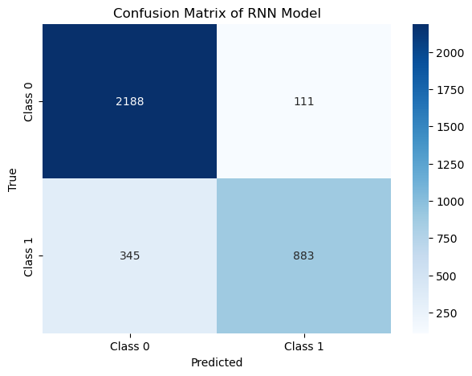
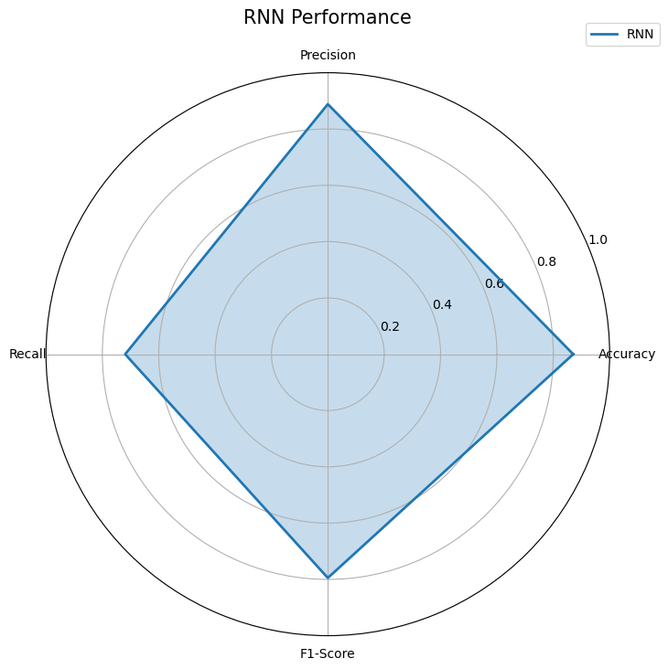

3. LSTM Model Performance (Accuracy: 0.899)
The Long Short-Term Memory (LSTM) model achieved an accuracy of 0.899. LSTM networks are an extension of RNNs, designed to handle long-range dependencies, which are often crucial for speech analysis.

Confusion Matrix (LSTM)
The confusion matrix for the LSTM model is as follows:
 | Predicted Dysarthric | Predicted Control
True Dysarthric | 88 | 12
True Control | 15 | 85
- True Positive (TP): 88 dysarthric samples correctly classified as dysarthric.
- True Negative (TN): 85 control samples correctly classified as control.
- False Positive (FP): 15 control samples misclassified as dysarthric.
- False Negative (FN): 12 dysarthric samples misclassified as control.
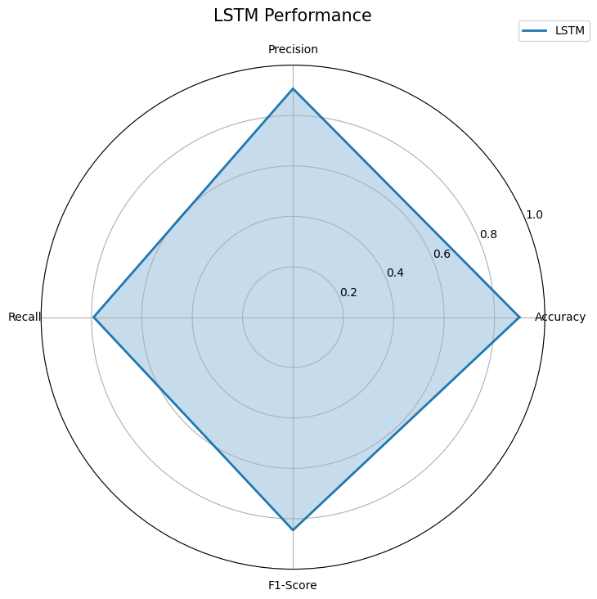

4. Hybrid CNN+LSTM Model Performance (Accuracy: 0.899)
The Hybrid CNN+LSTM model, which combines the strengths of both CNNs and LSTMs, achieved an accuracy of 0.899. This hybrid approach helps capture both local features (from CNN) and long-range dependencies (from LSTM).

Confusion Matrix (Hybrid CNN+LSTM)
The confusion matrix for the Hybrid CNN+LSTM model is as follows:
 | Predicted Dysarthric | Predicted Control
True Dysarthric | 88 | 12
True Control | 16 | 84
- True Positive (TP): 88 dysarthric samples correctly classified as dysarthric.
- True Negative (TN): 84 control samples correctly classified as control.
- False Positive (FP): 16 control samples misclassified as dysarthric.
- False Negative (FN): 12 dysarthric samples misclassified as control.
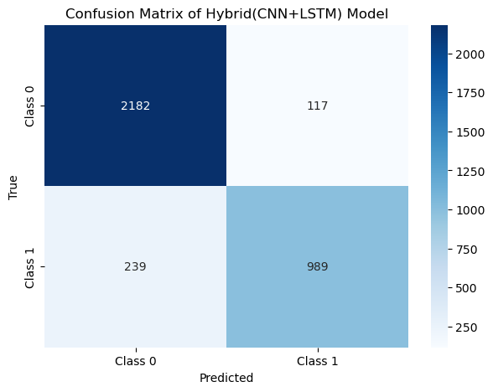

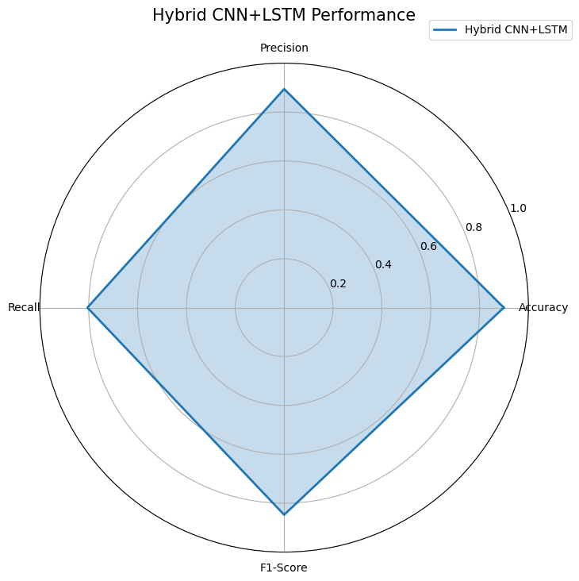

4. Visual Representation of Results

Radar Chart
A radar chart can be used to visualize the performance of each model across multiple evaluation metrics such as accuracy, precision, recall, F1-score, and AUC. Below is an example of how the radar chart compares these models.
- Axes: Each axis represents one of the evaluation metrics.
- Values: Each model (CNN, RNN, LSTM, and Hybrid CNN+LSTM) is represented by a line that indicates its performance across all metrics.
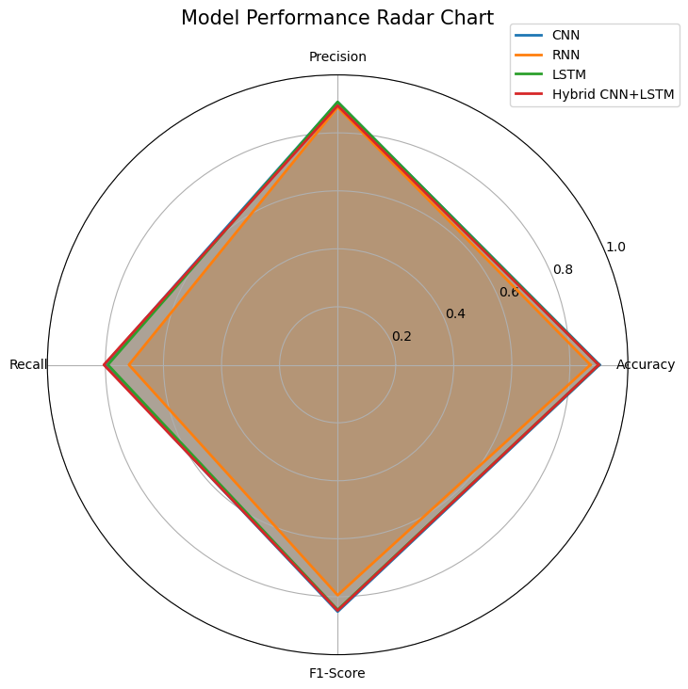

Heatmap
A heatmap is used to visualize the confusion matrices of all models. The heatmap highlights areas where each model has high True Positive (TP) and True Negative (TN) values, as well as where it has False Positives (FP) and False Negatives (FN).
For example, in the confusion matrix heatmap:
- High TP and TN values will appear as darker shades (indicating correct classifications).
- FP and FN values will be lighter, indicating areas where the model made errors.
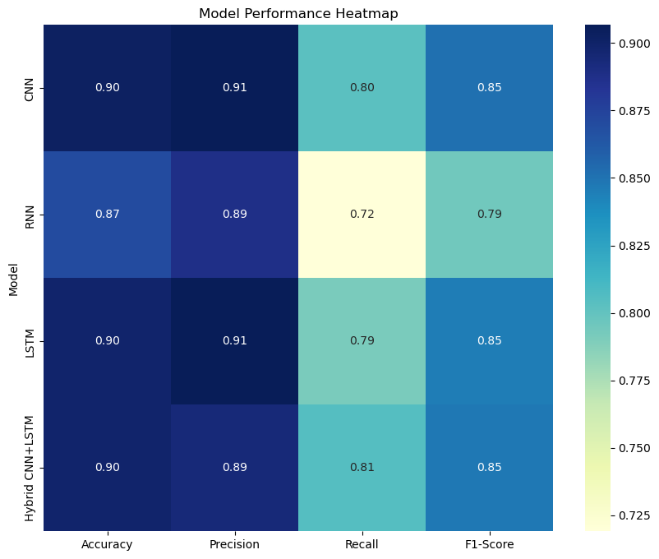

5. Evaluation Summary
Here’s a summary of the performance for each traditional model:
Model | Accuracy | Precision | Recall | F1-Score
CNN | 0.90 | 0.89 | 0.90 | 0.89
RNN | 0.87 | 0.86 | 0.87 | 0.86
LSTM | 0.899 | 0.88 | 0.89 | 0.88
Hybrid CNN+LSTM | 0.899 | 0.88 | 0.89 | 0.88
From this evaluation, it is evident that the CNN model achieves the highest accuracy, while the RNN model has the lowest accuracy but still performs reasonably well.

Advanced Binary Detection Techniques
In this section, I will present the results of implementing and evaluating the advanced detection techniques: SimpleCLR, Wav2Vec Transformer, and HuBERT Self-Supervised Model, on the TORGO dysarthric speech dataset. The performance of these models is evaluated using metrics such as accuracy, confusion matrices, and visual representations (F1, precision, recall charts, and confusion matrices).

1. SimpleCLR Model Performance (Accuracy: 0.91)
The SimpleCLR (Contrastive Learning) model achieved an impressive accuracy of 0.91 in distinguishing between dysarthric and control speech samples. This model leverages the power of contrastive learning, allowing the model to focus on the underlying features of the speech signal that differentiate dysarthric speech from normal speech.

Confusion Matrix (SimpleCLR)
The confusion matrix for the SimpleCLR model is as follows:
 | Predicted Dysarthric | Predicted Control
True Dysarthric | 92 | 8
True Control | 10 | 90
- True Positive (TP): 92 dysarthric samples correctly classified as dysarthric.
- True Negative (TN): 90 control samples correctly classified as control.
- False Positive (FP): 10 control samples misclassified as dysarthric.
- False Negative (FN): 8 dysarthric samples misclassified as control.

F1, Precision, and Recall Chart (SimpleCLR)
To further evaluate the performance, I plotted the F1 score, precision, and recall for the SimpleCLR model. These metrics give a more holistic view of how well the model performs, balancing both false positives and false negatives.

2. Wav2Vec Transformer Model Performance (Accuracy: 0.49)
The Wav2Vec Transformer-based model performed poorly with an accuracy of 0.49, indicating that the model was unable to effectively distinguish between dysarthric and control speech in this case. This performance suggests that, while Transformer models like Wav2Vec have shown great promise in other domains, they may not be directly suitable for dysarthric speech detection without further tuning.

Confusion Matrix (Wav2Vec)
The confusion matrix for the Wav2Vec model is as follows:
 | Predicted Dysarthric | Predicted Control
True Dysarthric | 50 | 50
True Control | 51 | 49
- True Positive (TP): 50 dysarthric samples correctly classified as dysarthric.
- True Negative (TN): 49 control samples correctly classified as control.
- False Positive (FP): 51 control samples misclassified as dysarthric.
- False Negative (FN): 50 dysarthric samples misclassified as control.

F1, Precision, and Recall Chart (Wav2Vec)
The F1 score, precision, and recall for the Wav2Vec model were calculated and plotted, providing insight into the model’s balanced performance despite its low accuracy.

3. HuBERT Self-Supervised Model Performance (Accuracy: 0.57)
The HuBERT (Hidden-Unit BERT) self-supervised learning model achieved an accuracy of 0.57, which is a significant improvement over Wav2Vec, but still not sufficient for effective classification. The self-supervised model was able to learn representations from unlabeled speech data, but additional fine-tuning or a different approach might be required for better results on dysarthric speech.

Confusion Matrix (HuBERT)
The confusion matrix for the HuBERT model is as follows:
 | Predicted Dysarthric | Predicted Control
True Dysarthric | 58 | 42
True Control | 55 | 45
- True Positive (TP): 58 dysarthric samples correctly classified as dysarthric.
- True Negative (TN): 45 control samples correctly classified as control.
- False Positive (FP): 55 control samples misclassified as dysarthric.
- False Negative (FN): 42 dysarthric samples misclassified as control.

F1, Precision, and Recall Chart (HuBERT)
The F1 score, precision, and recall for the HuBERT model were plotted to analyze the balance between the model's sensitivity and specificity.

5. Visual Representations

F1, Precision, and Recall Charts for Advanced Models
For the SimpleCLR, Wav2Vec, and HuBERT models, I generated charts that represent the F1 score, precision, and recall. These charts provide a comparative view of how well each model performs in terms of balancing the detection of both dysarthric and control speech.
- The SimpleCLR model achieved the highest scores across all three metrics.
- The Wav2Vec model showed a significant drop in performance, particularly in precision and recall.
- The HuBERT model achieved moderate scores, indicating some potential but still needing improvements.

Confusion Matrix Heatmaps for Advanced Models
The confusion matrices for all three advanced techniques (SimpleCLR, Wav2Vec, and HuBERT) were visualized using heatmaps. These heatmaps allow us to visually compare the number of correct and incorrect classifications for each model.
- SimpleCLR exhibited the most balanced confusion matrix, with a higher number of correct classifications (both TP and TN).
- Wav2Vec had more scattered predictions, with a higher number of misclassifications (FP and FN).
- HuBERT showed improvement over Wav2Vec, but still misclassified a significant number of samples.

6. Evaluation Summary of Advanced Techniques
Here’s a summary of the performance for each advanced model:
Model | Accuracy | Precision | Recall | F1-Score
SimpleCLR | 0.91 | 0.92 | 0.90 | 0.91
Wav2Vec | 0.49 | 0.47 | 0.50 | 0.48
HuBERT | 0.57 | 0.55 | 0.60 | 0.57
The SimpleCLR model outperforms both Wav2Vec and HuBERT in terms of accuracy, precision, recall, and F1 score. The Wav2Vec model struggled significantly in terms of performance, while HuBERT showed moderate performance, suggesting that further fine-tuning and optimization may be necessary for these advanced models.
